Math on the Farm

Story Problems

1. Corn is measured in bushels. Rick’s combine holds 800 bushels of corn. If he unloads 475 bushels of corn into a truck, how much is left? Show your equation and the strategy you used.
2. 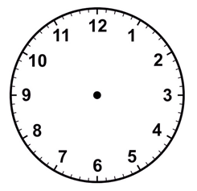Cows are milked three times a day. Daisy Dairy milks their cows at 6 a.m. They will milk again 8 hours later. What time should the cows go to the milking parlor? Write the time and draw it on the clock.
3. Farmers divide big pastures into smaller areas. They move the cows to a new area each day. This gives the cows fresh grass to eat. It also gives the grass time to grow before the cows return. Divide pasture below into 8 equal sections.
4. A farmer has 40 sheep. He sells half of them. How many are left?
5. Farmers raise chickens in a building called a coop. A coop protects the chickens and eggs from animals. Chickens lay one egg each day. There are three chicken coops on Anna’s farm. The first coop has 55 chickens. The second coop has 52 chickens. The third coop has 50 chickens. How many eggs will Anna have if she collects eggs from all of the coops? Show your equation and the strategy you used.
6. Some farmers sell fruit, vegetables, eggs, and meat at farmers markets. Linda sells 12 ears of sweetcorn for $5.75. Show three different ways you can pay. Write the number of each bill and coin you will use in the chart below.

|  |  |  |  |  |  |  |
| --- | --- | --- | --- | --- | --- | --- |
|  | **5 Dollar  Bills** | **1 Dollar  Bills** | **Quarters** | **Dimes** | **Nickels** | **Pennies** |
| **Option 1** |  |  |  |  |  |  |
| **Option 2** |  |  |  |  |  |  |
| **Option 3** |  |  |  |  |  |  |